Aman Patel

CSCI-B 455

March 7, 2021

Homework 3 Part 1

1. KNN points
   1. The closest $3$ points to $U$ are:
 $\left(2, 5\right):Orange$

 $\left(1, 2\right):Red$

 $\left(2, 6\right):Red$

2. If all neighbors have the same weight, $Red$ will be the classification, as it occurs the most frequently.
   3. If we use the inverse square of the distance:
 $Red=\frac{1}{{\left(1-1\right)}^{2}+{\left(4-2\right)}^{2}}+\frac{1}{{\left(1-2\right)}^{2}+{\left(4-6\right)}^{2}}=\frac{1}{4}+\frac{1}{5}=\frac{9}{20}$

 $Orange=\frac{1}{{\left(1-2\right)}^{2}+{\left(4-5\right)}^{2}}=\frac{1}{2}$

 $\frac{1}{2}>\frac{9}{20}∴Orange$   1. is the classification.
2. Case-based diagnosis
   1. Similarity between all cases and $q=(high, no, no, no)$
      1. Case 1: $0.3*0.2+0.2*1+0.2*1+0.3*1= 0.76$
      2. Case 2: $0.3*0.7+0.2*1+0.2*1+0.3*1=0.91$
      3. Case 3: $0.3*1+0.2*1+0.2*1+0.3*0.2=0.76$
      4. Case 4: $0.3*1+0.2*0.2+0.2*0.2+0.3*1=0.68$
      5. Case 5: $0.3*0.7+0.2*1+0.2*0.2+0.3*1=0.75$
      6. Case 6: $0.3*0.2+0.2*0.2+0.2*0.2+0.3*1=0.44$
      7. Case 7: $0.3*0.7+0.2*0.2+0.2*0.2+0.3*1=0.59$
   2. Similarity between all cases and $q=\left(?, yes, no, yes\right)$
      1. Case 1: $0.2* 0+0.2*1+0.3* 0=0.2$
      2. Case 2: $0.2* 0+0.2*1+0.3* 0=0.2$
      3. Case 3: $0.2* 0+0.2*1+0.3* 1=0.5$
      4. Case 4: $0.2* 1+0.2*0.2+0.3* 0=0.24$
      5. Case 5: $0.2* 0+0.2*0.2+0.3* 0=0.04$
      6. Case 6: $0.2* 1+0.2*0.2+0.3* 0=0.24$
      7. Case 7: $0.2* 1+0.2*0.2+0.3* 0=0.24$
   3. Nearest neighbors and diagnosis:
      * 1. Case 2, output: $Influenza$ $(I)$
 $q=(?, yes, no, yes)$

       2. Case 3, output: $Influenza (I)$
3. K nearest neighbor with linear separator
   1. Mr. Fuzzy is incorrect because he does not take border cases into account. For example, see the graph below:
   2. 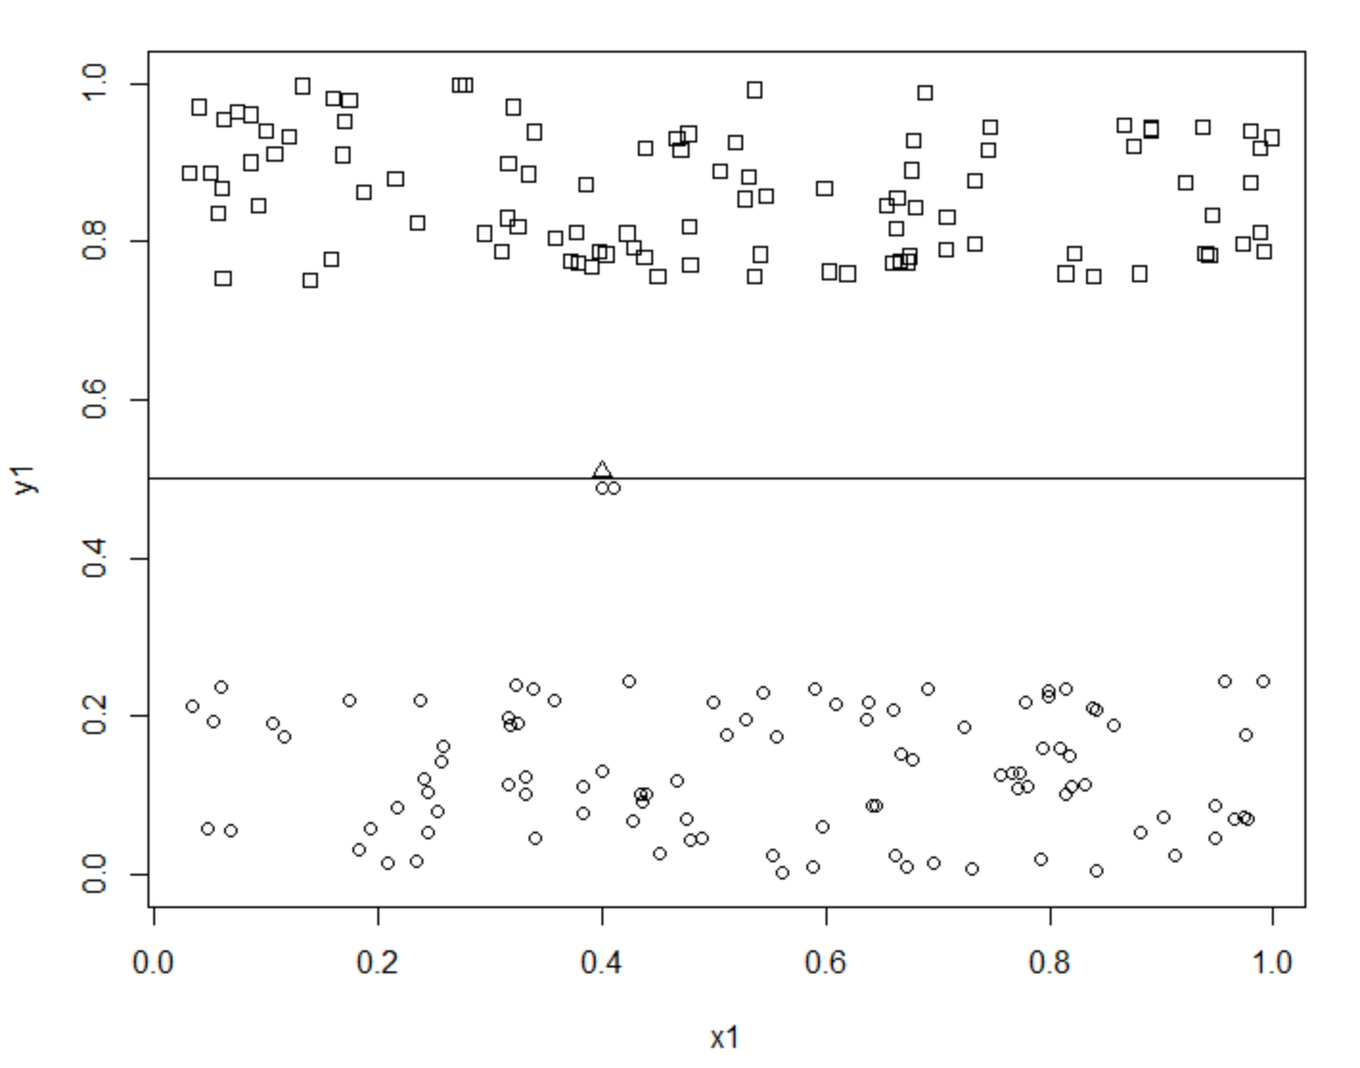
   3. The triangle near the center line is above the partition and should therefore be classified as a member of the top group. However, if the k-nearest neighbors algorithm is used for $k≤4$, it will incorrectly be classified as a member of the bottom group.